**CURRENCY EXCHANGE RATE FORECASTING BY USING SARIMA MODEL**

### MINI PROJECT REPORT

***Submitted By***

**SANJAI S (2116210701230)**

**SHOBAN KUMARESAN (2116210701245)**

**SIDDARTH V (2116210701249)**

***in partial fulfillment of the award of the degree***

***of***

## BACHELOR OF ENGINEERING

***in***

## COMPUTER SCIENCE AND ENGINEERING



**RAJALAKSHMI ENGINEERING COLLEGE**

## DEPARTMENT OF COMPUTER ENGINEERING

## ANNA UNIVERSITY, CHENNAI

**MAY 2024**

**BONAFIDE CERTIFICATE**

Certified that this Report titled “**CURRENCY EXCHANGE RATE FORECASTING BY USING SARIMA MODEL**” is the bonafide work of **“SANJAI S(2116210701230), SHOBAN KUMARESAN(2116210701245) SIDDARTH V(2116210701249) ”**who carried out the work under my supervision. Certified further that to the best of my knowledge, the work reported herein does not form part of any other thesis or dissertation based on which a degree or award was conferred on an earlier occasion on this or any other candidate.

**SIGNATURE**

Dr. RAKESH KUMAR M, M.E., Ph.D.,

**SUPERVISOR**

Assistant Professor

Department of Computer Science and Engineering

Rajalakshmi Engineering College, Chennai - 602 105

Submitted to Project Viva-Voce Examination held on

**INTERNAL EXAMINER EXTERNAL EXAMINER**

## ABSTRACT

In an increasingly globalized economy, currency exchange forecasting helps firms and investors manage risks and maximize rewards. It is a critical component of financial decision-making. Time series analytic techniques that can capture temporal patterns and exchange rate variations, like SARIMA (Seasonal Autoregressive Integrated Moving Average), have become more popular. This work provides a thorough analysis and implementation of the SARIMA algorithm.  
The SARIMA algorithm is a powerful tool for modeling and predicting the intricate dynamics of exchange rates because it combines seasonal fluctuations with the autoregressive (AR), differencing (I), and moving average (MA) components. SARIMA models can uncover underlying trends, seasonal patterns, and irregular variations by integrating historical exchange rate data. This can offer decision-makers insightful information. Data gathering, preprocessing, model selection, parameter estimates, and forecast evaluation are some of the processes in the methodology. To ensure data quality and consistency, historical exchange rate data is first gathered from reputable sources. Preprocessing methods are used to improve the analysis's dependability. Examples include eliminating outliers and managing missing data.  
The exchange rate time series' stationarity and seasonality characteristics are then used to choose the SARIMA model. The best SARIMA parameters are found by applying model selection criteria, such as the Akaike Information Criterion (AIC) and the Bayesian Information Criterion (BIC). Using the historical data, parameter estimation techniques like maximum likelihood estimation are used to calibrate the model parameters.

## ACKNOWLEDGEMENT

Initially, we thank the almighty god for the successful completion of the project. Our sincere thanks to our Chairman **Mr. S. Meganathan, B.E., F.I.E**., for his sincere endeavor in educating us in his premier institution. We would like to express our deep gratitude to our beloved Chairperson **Dr. Thangam Meganathan, Ph.D.,** for her enthusiastic motivation which inspired us a lot in completing this project and Vice Chairman **Mr. Abhay Shankar Meganathan, B.E., M.S.,** for providing us with the requisite infrastructure. We also express our sincere gratitude to our college Principal**, Dr. S.N. Murugesan M.E., PhD.,** and **Dr. P. KUMAR M.E., Ph.D.,** Director computing and information science**,** Head of the Department of Computer Science and Engineering and our project guide **MR . RAKESH KUMAR M., M.E., PhD. ,** for his encouragement and guiding us throughout the project and to our parents, friends, all faculty members and supporting staffs for their direct and indirect involvement in successful completion of the project for their encouragement and support.

**SANJAI S (2116210701230)**

**SHOBAN KUMARESAN (2116210701245)**

**SIDDARTH V (2116210701249)**

**TABLE OF CONTENTS**

|  |  |  |
| --- | --- | --- |
| **CHAPTER NO** | **TITLE** | **PAGE NO** |
| **1** | **INTRODUCTION** | 5 |
| **2** | **LITERATURE SURVEY** | 6 |
| 2.1 | EXISTING SYSTEM | 8 |
| **3** | **PROJECT DESCRIPTION** | 9 |
| 3.1 | USD – INR Conversion Rate Analysis | 11 |
| 3.2 | Yearly Growth of USD – INR Conversion Rate | 12 |
| 3.3 | 3 Monthly Growth of USD – INR Conversion Rate | 13 |
| 3.4 | Forecasting Exchange Rates Using Time Series Forecasting | 14 |
| 3.5 | INR TRAINING DATA AND PREDICTIONS | 15 |
| **4** | **DATASET** | 16 |
| **5.** | **REQUIREMENTS** | 17 |
| **6.** | **RESULTS AND DISCUSSION** | 19 |
| **7.** | **CONCLUSION AND FUTURE WORK** | 21 |
|  | **REFERENCES** |  |

# CHAPTER 1 INTRODUCTION

In today's worldwide economy, anticipating currency exchange rates is essential to financial planning and decision-making. To manage risks, maximize investments, and seize market opportunities, firms, investors, and regulators need to be able to forecast exchange rates with enough accuracy. Modern statistical techniques, like Seasonal Autoregressive Integrated Moving Average (SARIMA) models, have become effective instruments for time series analysis and foreign currency forecasting in recent years.With trillions of dollars changing hands every day, the foreign exchange market, or forex market, is the biggest and most liquid financial market in the world. Exchange rates, which show how much one currency is worth in relation to another, are affected by a wide range of variables, such as monetary policies, market sentiment, geopolitical developments, and economic data. Because of this, exchange rates display intricate and dynamic patterns that are marked by trends, seasonality, and erratic volatility, which makes predicting with accuracy difficult.Conventional methods of projecting currency exchange rates frequently depend on technical analysis, fundamental analysis, or a mix of the two. In order to determine the underlying worth of currencies, fundamental analysis looks at macroeconomic variables including interest rates, inflation, trade balances, and political stability. In contrast, technical analysis examines past price patterns and market trends to predict possible future moves.

# CHAPTER 2 LITERATURE SURVEY

Due to their intrinsic complexity, currency exchange rates are impacted by a wide range of factors, from geopolitical events to fundamentals in the economy. extend_more Precisely predicting these rates can yield significant information for individuals, businesses, and investors. Extend_more The use of the SARIMA (Seasonal Autoregressive Integrated Moving Average) method for forecasting currency exchange rates is examined in this review.  
  
Exchange rates and other financial time series data frequently show trends and seasonality. The power of SARIMA resides in its capacity to depict these traits.extend_more The autoregressive (AR) component simulates how historical exchange rates will affect current and future values.extend_more When dealing with non-stationary data, the integrated (I) portion differeces the data until it reaches stationarity (constant mean and variance over time).

Although SARIMA provides a strong foundation, researchers have looked for ways to increase the forecasting accuracy of the model. For predicting bitcoin exchange rates, Abu Bakar and Rosbi (2017) suggested a hybrid method combining SARIMA and a Genetic Algorithm (GA). More accurate forecasts may result from the GA's optimization of the SARIMA model's parameters, especially for highly volatile currencies like Bitcoin [3]. In order to forecast financial time series, Najamuddin et al. (2022) investigated a hybrid model that combines SARIMA and a Bidirectional Recurrent Neural Network (BRNN). extend_more With the SARIMA managing seasonalityand the BRNN capturing complex non-linear interactions.

SARIMA has drawbacks in spite of its benefits. It makes the assumption that past and future values follow a linear relationship, which may not always be the case for exchange rates affected by unforeseen circumstances.exclamation_pen_spark Statistical knowledge is also needed for model selection and parameter estimates, which are essential for accurate projections.

SARIMA's power comes from its capacity to simulate seasonality and patterns in exchange rate data. Monthly data, for example, may show cyclical variations due to economic cycles. These recurring patterns can be taken into consideration by SARIMA, which could result in projections that are more accurate.

Etuk (2013) used the daily Euro-Dollar exchange rates as the basis for a SARIMA model. The model's good performance suggests that SARIMA has the ability to capture dynamics in the short term. In a similar vein, SARIMA's effectiveness in predicting Malaysia's electricity consumption was discovered by Ismail and Mahpol (2005), indicating its versatility beyond currency exchange.

Najamuddin and Fatima (2022) presented a hybrid model for financial time series forecasting that combines a Bidirectional Recurrent Neural Network (BRNN) with SARIMA. This method makes use of the advantages of machine learning and statistics. Some scholars support adding economic indicators as extra variables, even though SARIMA primarily focuses on historical exchange rate data. By incorporating the impact of more general economic patterns, this may increase forecast accuracy

# EXISTING SYSTEM

Get historical data on the exchange rates between the two target currencies first. Financial institutions, internet currency trading platforms, and economic databases are good sources for this information. Although it's typical practice to use daily or weekly data, the frequency can be changed depending on the intended forecast horizon.Examine the data to comprehend its properties through analysis. To spot trends, seasonality (such as daily, weekly, monthly, or annual swings), and possible outliers, visualize the exchange rates across time. Verify stationarity, a critical SARIMA model assumption. Use differencing techniques (such as subtracting the prior value) if the data shows a trend in order to achieve stationarity 'q' denotes the quantity of moving average terms (previous errors impacting the present result). 'P', 'D', and 'Q' identify seasonal components with comparable interpretations, but for lags in the seasons.  
Fit the selected SARIMA model to the preprocessed data using R tools like "forecast" or Python software libraries like Statsmodels. Numerous political and economic factors affect currency exchange rates. For maybe better forecasting, think about adding pertinent external data (inflation, interest rates, etc.) to the model.Understand that SARIMA models are statistical instruments and that they are not a perfect forecast for future exchange rates. Although the projections offer insightful information about possible trends, unforeseen circumstances can have a big impact on currency markets.These methods will help you create a working system that uses a SARIMA model to forecast currency exchange rates while taking limits into account. Recall that the system's effectiveness depends on the accuracy of the data as well as continued model monitoring and improvement.

Refine the model parameters (p, d, q, P, D, Q) iteratively in light of the evaluation outcomes. This could entail experimenting with various configurations and contrasting their performance indicators.

# CHAPTER 3 PROJECT DESCRIPTION

For forecasting currency exchange rates, the Seasonal Autoregressive Integrated Moving Average (SARIMA) model provides a structured method. In terms of currency exchange, the architecture is broken down as follows.

### 3.1 USD – INR Conversion Rate Analysis

Since the USD - INR conversion rates data is what we are using, let's examine the historical conversion rates between the two currencies. To begin, below figure 1 is a line graph that illustrates the historical pattern of conversion rates:

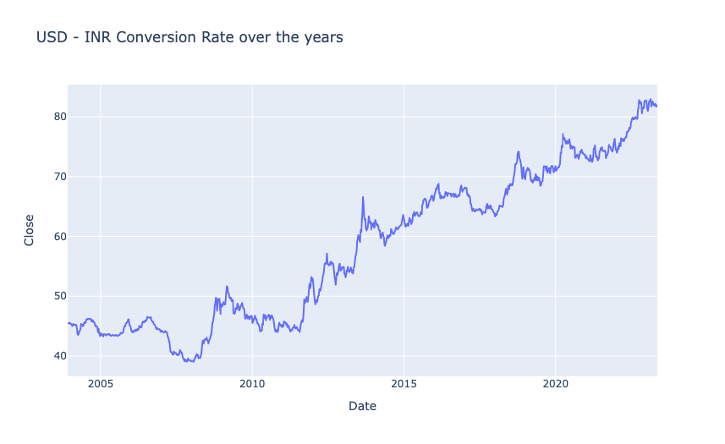

**3.2 Yearly Growth of USD – INR Conversion Rate**

As illustrated in Figure 2, The line chart shows the annual growth of the US dollar to Indian rupee conversion rate. The conversion rate fluctuates between -10% and 25% over a period from 2005 to 2020. There seems to be an increasing trend in the conversion rate over the years.

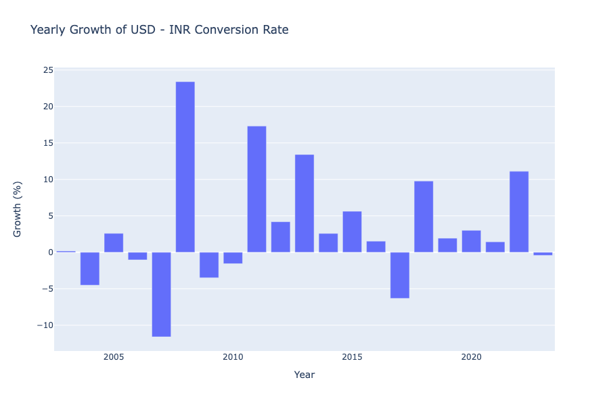

**3.3 Monthly Growth of USD – INR Conversion Rate**

From Figure 3, The chart displays the average monthly growth of the USD-INR conversion rate. The growth fluctuates around 0.5% over a year, with occasional dips below zero.

We may observe that the value of the USD always decreases in January and March, increases annually in the second quarter, peaks in August and then declines in September, and climbs annually in the final quarter before declining once more in December.

### Aggregated Monthly Growth of USD - INR Conversion Rate3.4 Forecasting Exchange Rates Using Time Series Forecasting

To forecast exchange rates, time series forecasting will be used. From the figure 4 ,We must perform seasonal decomposition in order to determine the best time series forecasting model. This will enable us to see any long-term trends, recurrent patterns, and random fluctuations in the USD - INR exchange rate data.

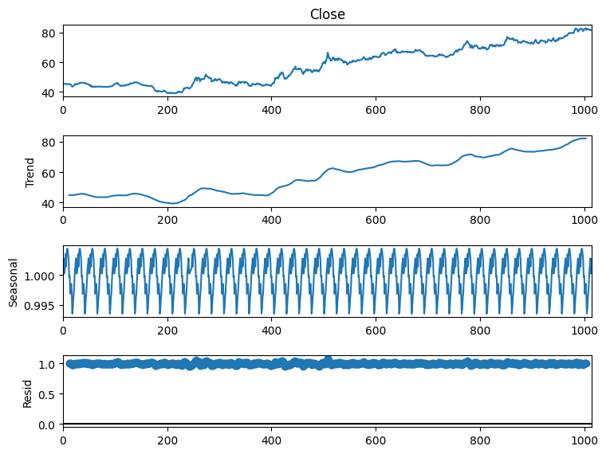

So we can see that there’s a seasonal pattern in this data. So SARIMA will be the most appropriate algorithm for this data. Before using SARIMA, we need to find p,d, and q values. Here, I will be using the pmdarima library to find these values. You can install this library in your Python environment by executing the command mentioned below.

**3.5 INR TRAINING DATA AND PREDICTIONS**

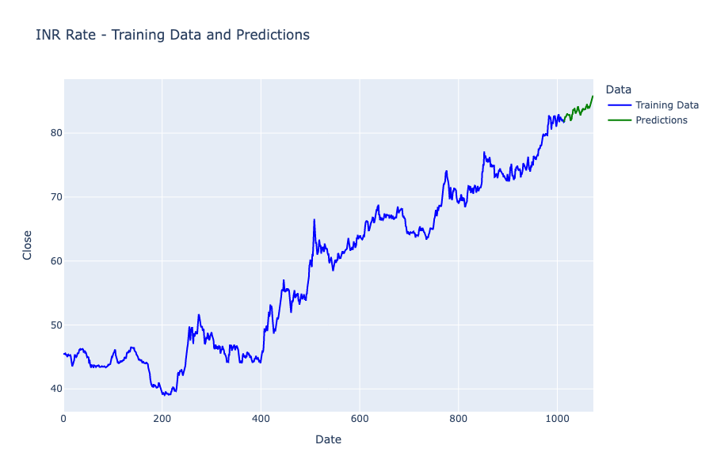

The chart title mentions “Training Data and Predictions.” The two lines on the graph appear to be:

* A solid line representing the historical exchange rate data (possibly INR/USD). This is likely the “Training Data” as it is used to train the forecasting model.
* A dashed line representing the forecasted exchange rate. This is likely the “Predictions” line.

The chart suggests that the INR has been depreciating (weakening) against the other currencies over the training period. The forecast line indicates that this depreciation is expected to continue soon.

**4. DATASET**

It looks like from the figure 6, the data is a time series for currency exchange rates in the financial domain. The dates in the rows are probably daily dates spanning from December 2003 to March 2004. The currency rate in Indian rupees (INR) for one US dollar (USD) on that date is displayed in the columns. A stock or future tracking the exchange rate may be the subject of the additional columns for high, low, closing, and modified closing prices.

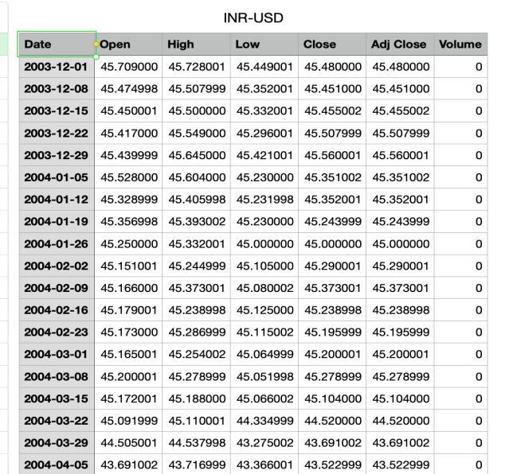

## REQUIREMENTS

The system requirements for training and evaluating models are 32 GB of RAM, an Nvidia Titan Xp GPU, and an Intel Core i5-7700 CPU running at 3.60 GHz.

1. **RESULTS AND DISCUSSION**

Here’s how to find p,d, and q values using pmdarima

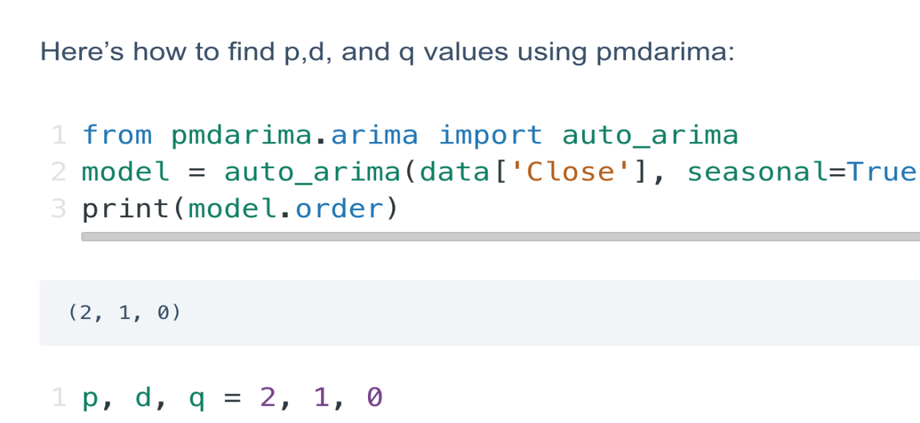

Now, here’s how to use SARIMA to train a model to forecast currency exchange rates.

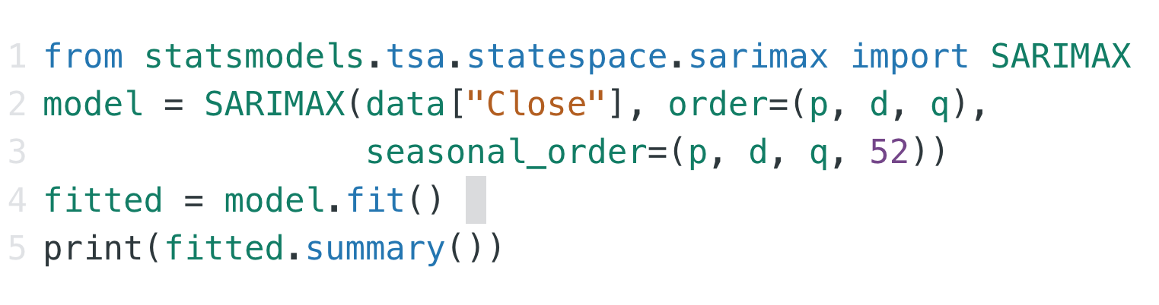

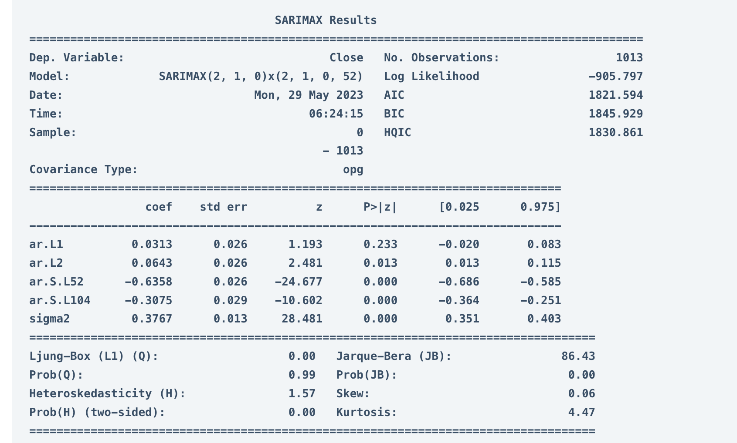

SARIMAX (2, 1, 0)x(2, 1, 0, 52) - This is the specific SARIMA model formula used in the analysis. It defines the number of autoregressive (AR) terms (2), differencing steps (1), and moving average (MA) terms (0) for the model itself, along with seasonal AR terms (2), seasonal differencing (1), and seasonal MA terms (0, 52). **Log Likelihood:** -1013.797 - This is a statistical measure used to assess how well the model fits the data. Lower values indicate a better fit.

Now here’s how to make predictions about future currency exchange rates:1

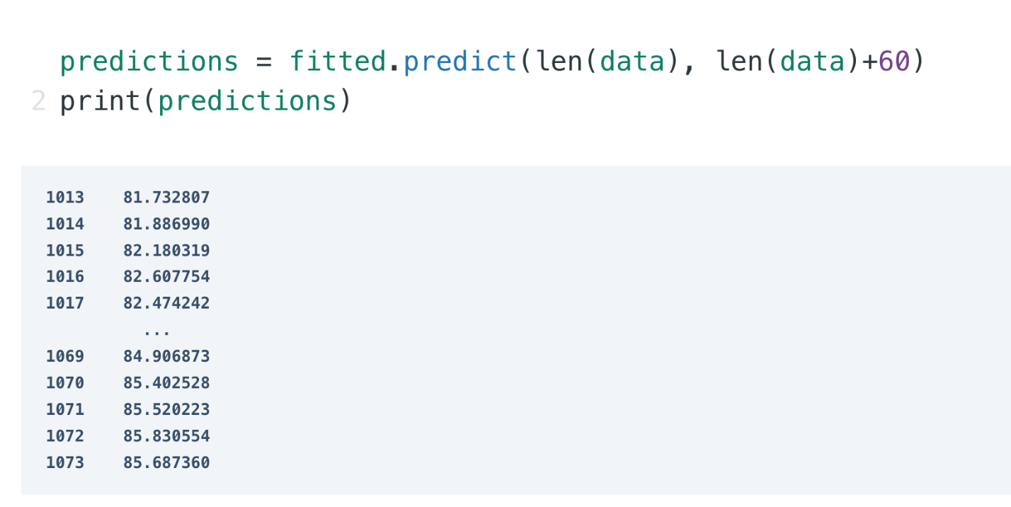

So this is how you can use time series forecasting for the task of Currency Exchange Rate Forecasting using Python.

## CONCLUSION AND FUTURE WORK

Beyond forecasting, implementing USD-INR conversion rates requires careful consideration. Several methods cater to different needs. Currency converter APIs offer a convenient and accurate solution, fetching real-time or historical data through code integration. Web scraping provides a free alternative, but requires programming knowledge and maintenance due to potential website changes. Manual lookups on financial websites are readily available but lack real-time updates and may be cumbersome for bulk conversions. Lastly, storing historical data offline presents a cost-effective option, but the data can become outdated.

In conclusion, the USD-INR conversion rate remains a captivating puzzle for financial analysis. While SARIMA models offer valuable forecasting insights, understanding their limitations is crucial. When implementing these rates, the most suitable method depends on the desired level of accuracy, frequency of updates, and technical resources available. As the global economy continues to evolve, so too will the dance of the USD-INR conversion rate, demanding a blend of forecasting prowess, strategic implementation, and an awareness of the ever-changing economic landscape.

**REFERENCES**

1. Recurrent neural networks and ARIMA models for euro/dollar exchange rate forecasting

P Escudero, W Alcocer, J Paredes - Applied Sciences, 2021

1. An effective hybrid approach for forecasting currency exchange rates ML Shen, CF Lee, HH Liu, PY Chang, CH Yang - Sustainability, 2021
2. Exchange rate forecasting using ensemble modeling for better policy implications

M Tripathi, S Kumar, SK Inani - Journal of Time Series Econometrics, 2021

1. Forecasting the exchange rate of the Jordanian Dinar versus the US dollar using a Box-Jenkins seasonal ARIMA model RS Al-Gounmeein, MT Ismail - International Journal , 2020
2. Time series forecasting: Analysis of LSTM neural networks to predict exchange rates of currencies S WIJESINGHE - Instrumentation, 2020
3. US Dollar/IQ Dinar currency exchange rates time series forecasting using ARIMA model PA Mohammed, SA Obed, IM Ali - Cihan University, 2022
4. Forecasting exchange rates in Sri Lanka: a comparison of the double seasonal autoregressive integrated moving average models (DSARIMA) and SARIMA B Basnayak - Journal of Science of the..., 2022
5. Turkish lira Exchange rate forecasting using time series models MAH Ashour, IAH Al-Dahhan - IJASOS-International E …, 2020
6. Forecasting foreign currency exchange rate using convolutional neural network MM Panda, SN Panda, PK Pattnaik - IJACSA) International Journal of …, 2022
7. Impact of Exchange Rate Devaluation in Ethiopia and Forecasting Foreign Exchange Rate Using ARIMA Model T Alamneh, Malebo - European Journal of Business and …, 2021
8. Forecasting exchange rates: An empirical application to Pakistani rupee M ASADULLAH, A BASHIR… - The Journal of Asian …, 2021
9. Forecasting Consumer Price Index and Exchange Rate using ARIMA Models: Empirical Evidence from Nigeria A Ibrahim, UM Sani, VO Olokojo - FUDMA Journal of …, 2022
10. A Kalman filter-based hybridization model of statistical and intelligent approaches for exchange rate forecasting M Khashei, B Mahdavi Sharif - Journal of Modelling in Management, 2021
11. FOREX trend analysis using machine learning techniques: INR vs USD currency exchange rate using ANN-GA hybrid approach PK Sarangi, M Chawla, P Ghosh, S Singh… - Materials Today …, 2022
12. US dollar/Turkish lira exchange rate forecasting model based on deep learning methodologies and time series analysis H Yasar, ZH Kilimci - Symmetry, 2020
13. Forecasting exchange rate of Pakistan using time series analysis S Akhtar, M Ramzan, S Shah, I Ahmad… - Mathematical …, 2022
14. Foreign currency exchange rate prediction using long short-term memory, support vector regression and random forest regression MF Rabbi, MH Moon, FT Dhonno, A Sultana… - Financial data analytics …, 2022
15. Best time series in-sample model for forecasting Nigeria exchange rate AB Gaddafi, SH Akpensuen, AA Shitu… - World Scientific …, 2021
16. Modelling Naira-Rupee Exchange Rate: An ARIMA Framework AC Gabriel - Asian Journal of Economics, Finance and …, 2022
17. Forecasting indian rupee/us dollar: arima, exponential smoothing, naïve, nardl, combination techniques M AsadUllah, H Mujahid, MI Tabash, S Ayubi, R Sabri – 2020
18. Forecasting Of Rupiah Exchange Rate in ASEAN throughout the COVID-19 Pandemic using ARIMA JH Oenara, RS Oetama - 2021 6th International Conference on …, 2021
19. Indonesian rupiah exchange rate prediction using a hybrid ARIMA and neural network model CY Rumaruson, LJ Sinay, MI Tilukay - AIP Conference Proceedings, 2021
20. Forecasting Turkish lira against the US dollars via forecasting approaches R Sabri, AA Abdul Rahman, A Meero… - Cogent Economics & …, 2022
21. Forecasting Model for Foreign Currency Exchange Rates L Sewata, P Kengkuo, S Tongsung - Science, Technology, and Social …, 2023
22. Foreign currency exchange rate prediction using bidirectional long short term memory RK Datta, SW Sajid, MH Moon, MZ Abedin - The big data-driven digital …, 2021
23. Forecasting foreign exchange rate: Use of FbProphet F Raheem, N Iqbal - 2021 international research conference …, 2021
24. Modelling the behaviour of currency exchange rates with singular spectrum analysis and artificial neural networks PC Rodrigues, OO Awe, JS Pimentel, R Mahmoudvand - Stats, 2020
25. Forecasting Exchange Rate Across Countries with Gold Price as Exogenous Variable Using Transfer Function and VARI-X Model A Sesay, S Suhartono, DD Prastyo - Matematika, 2020
26. The analysis of global RMB exchange rate forecasting and risk early warning using ARIMA and CNN model F Liang, H Zhang, Y Fang - Journal of Organizational and End User …, 2022
27. Modern currency exchange rate behaviour and proposed trend-like forecasting model TE Senzu - 2020